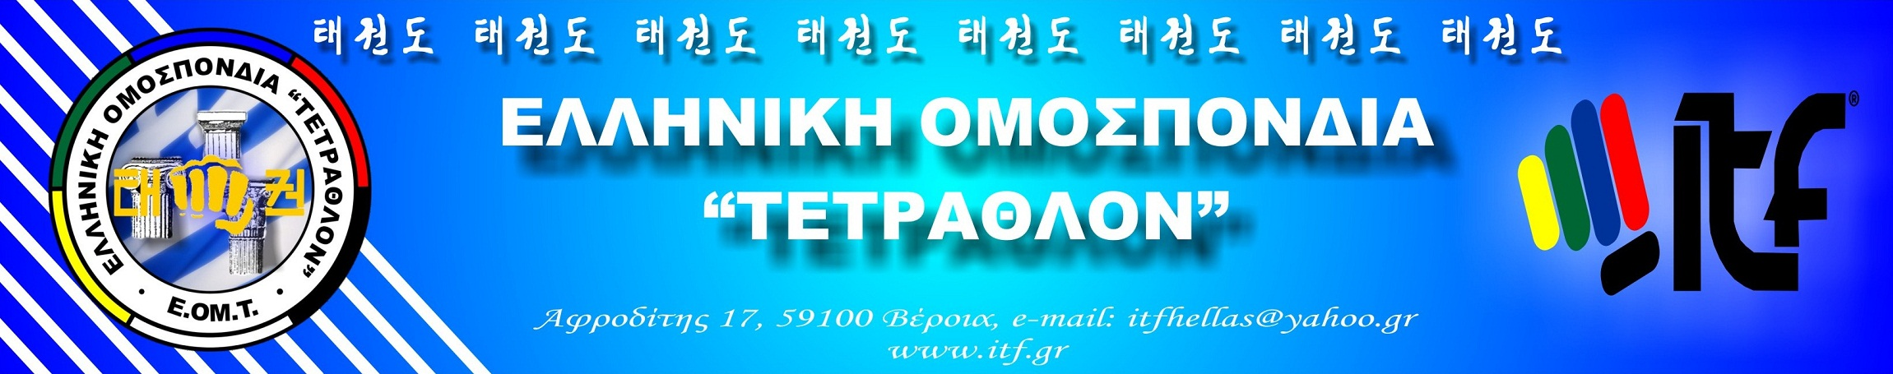

Veroia 20 January 2013
Nr. Pr. 28

To: International Taekwon-Do Federation
All Europe Taekwon-Do Federation

Subject: report for the National Course in Athens

OFFICIAL INVITATION OF THE HELLENIC NATIONAL COURSE AND PROMOTION DEGREE TEST - ATHENS 2013

The Hellenic Quadrathlon ITF Federation will be held national technical - umpire seminar and promotion degree test.

Date and place of the seminar and promotion test:
The seminar will be held on Saturday and Sunday 30-31 March 2013, in N. Makri - Athens.
After the seminar will be conducted examinations Dan and national referees.
The members can participate are for 4th to 1st Gup and 1st Dan and above.
For National Umpire test will be conducted after completion of examination Dan. To participate in international umpire seminar should have participation in national seminar.

Registrations:
Entries made in writing to the email of the federation, itfhellas@yahoo.gr.
Documents for submitting the application:
a) Application of EOMT with all items completed.
b) ID Athletic properties, certified by the EOMT and physician validate all data Gup, Dan and national - international seminars.
The participating members should be the official dobok of the ITF without advertising companies who are not official sponsors of the ITF - EOMT. The belts of athletes should indicate the requirements of the regulations of the ITF. If they do not participation can wear tracksuits their clubs, but not other similar sports federations etc.

Program:
Saturday, March 30, 2013
a) 11:00 to 13:30 Seminar Syllabus practical courses, technical analysis of the patterns (shadowboxing), teaching - syllabus.
b) 15:30 - 17:30, Technical sparring, Coaching, combinations of techniques. Theory – Umpiring.
Sunday, March 31, 2013
a) 10:30 to 12:30 Technical Sparring, coaching, technical combinations. Theory - Umpiring.
b) 13:45 to 14:30, Exams Dan – Umpiring.

Accommodation - Cost:
The members will be staying at their own risk. Offer Hotel stay: MARATHON EURO HOTEL, KORDATZAKIS KON / NOS, St. Panteleimon 25-27a, Marathon, tel 22940-57366-55122.
Single 40 Euro, Double 40 Euro, 50 Euro Triple, Quadruple 60 Euros.
Organizing members of EOMT: Mr. Pantazis Konstantinos 6th Degree – Mr. Karaoulis Konstantinos 4th Degree.

Officers Course and Exam:
The seminar was organized under the responsibility of the BD and Technical Committee of EOMT.

Mst. Panagiotis Gialamas
President

